**2014-2015 Indoor Schedule**

**November 2014**

* **3rd** – First day of practice

**December 2014**

* **5th** – Milwaukee, WI – Developmental Meet – UW-Milwaukee (Friday)
  + Cost: $15.00 per athlete

**January 2015**

* **10th** – Rockford, IL – Coach O Indoor Invite – Auburn High School
* Cost: $20.00 per athlete
* **10th** – Milwaukee, WI – Developmental Meet – UW-Milwaukee (Optional)
  + Cost: $15.00 per athlete
* **16th – 18th** – Rockford, IL – AAU Northern Indoor – Auburn High School
* Cost: $40.00 per athlete

**February 2015**

* **7th** – Champaign, IL – 7th Annual Dorothy Dawson – Univ. of Illinois
  + Cost: $8.00 per event
* **8th** – Kenosha, WI – WI USATF Indoor – Carthage College
  + Cost: $7.00 per event

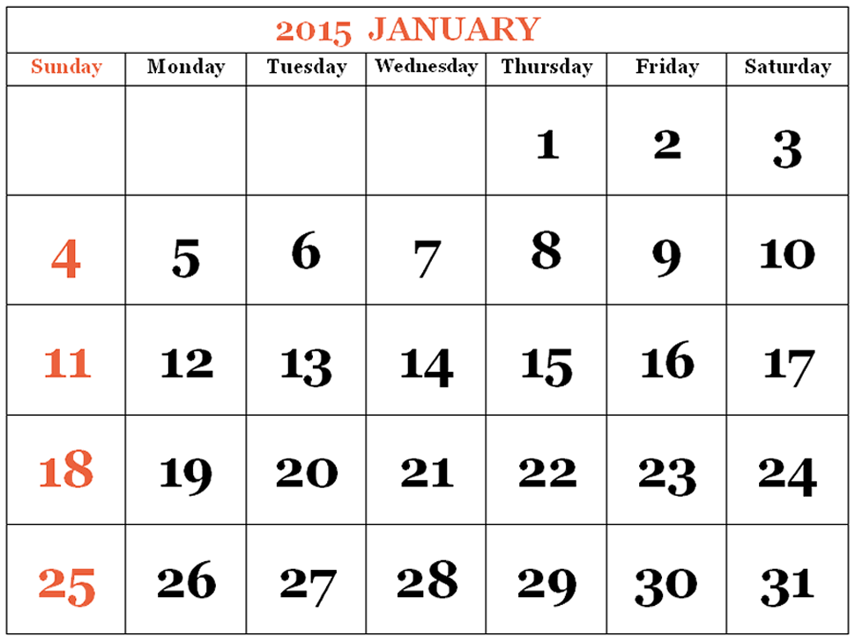 

**Notes:**

* January 17th Rockford Fire Meet – Cancelled: Replaced w/ AAU Northern Indoor
* Champaign meet **February 7th**: Will not participate at Kenosha on 2/8/15. Meet in Champaign will last all day.
  + **Hotel**: Friday, 2/6/15, La Quinta Inn Champaign, 1900 Center Drive, Champaign, IL 61820, $72.00/night – Book reservations on your own (Priceline or Hotelguides.com)